New Court Surgery Newsletter

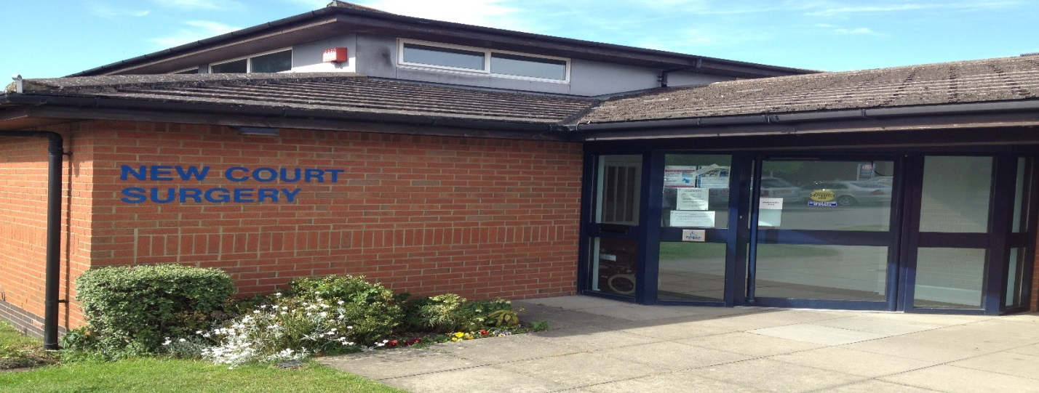

Borough Fields, Royal W
Welcome
Practice Manager: Mrs Kim Hiles
Borough Fields, Royal Wootton Bassett, Wiltshire, SN4 7AX
Tel 01793 852302
www.newcourt-wilts.nhs.uk Spring/Summer 1st Edition

Hello and welcome to our first newsletter, we hope you enjoy reading the information and news in this Spring/Summer edition.
New facility for ordering Prescriptions online

You can now order repeat prescriptions with our new Vision Online Service. With effect from 01 April 2015 the email method has been phased out. Patients will now have to register for the more secure method of Vision Online (form available at reception). When completed the form must be handed into reception along with two proofs of identifi cation, one of which must be photo id, this is to ensure patient safety. In the coming months patients will be able to apply for access to certain parts of their own medical records. Repeat prescriptions can still be ordered through the chemist or by filling in one of the repeat slips and posting it in the box provided in reception.
Text

We hope to start using mobile phone numbers to remind our patients of their appointments in the coming months. If you are happy for us to send you text messages to your mobile phone please ensure we have your correct mobile number and a signed consent form, available from reception. This will hopefully cut down on the number of DNA or unattended appointments we get each week. If you are unable to attend your appointment please cancel in plenty of time so as to allow somebody else to re book it.

Staff Changes

At the end of December Dr O’Brien left for a surgery in Shrivenham after being a partner here for many years, we wish her all the best in her new chapter. Her replacement is Dr David Marshall who joins us from a Practice in Berkshire, he has a special interest in performing Minor Operations here in general practice.
Travel Advice

Don’t travel abroad without ensuring that you’ve had the right vaccinations. We provide a comprehensive travel clinic service, customised to your individual needs, where we can offer pre-travel consultations and will assess the impact of any pre-existing medical conditions on your vaccine requirements. We have the full range of travel vaccines available on the NHS or private. New Court Surgery is a registered Yellow Fever center and is able to dispense Anti-Malarials. Full lists of our private fees are available in reception and on the website.
Carers

Here at the Surgery we understand how caring for a loved one can take its toll on you. The majority of our staff are Dementia Friends, whereby we undertook Dementia training with a member from the Alzheimer’s Association. The Surgery offers carers a yearly health check and also an annual flu jab.
On May 20th we joined forces with Tinkers Lane Surgery and Carer Support Wiltshire to put on a Country Garden themed Coffee and cake afternoon at Tinkers Lane Surgery. The afternoon was a huge success, not least because of the cakes!
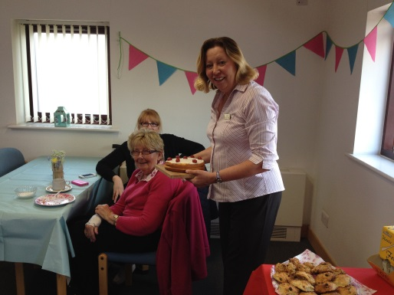
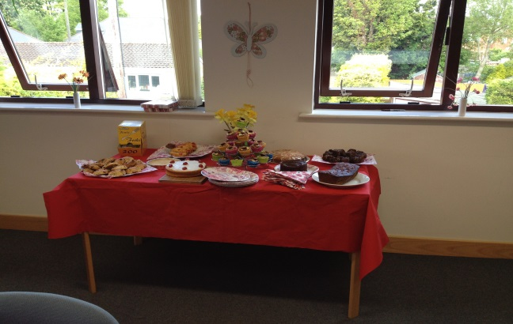
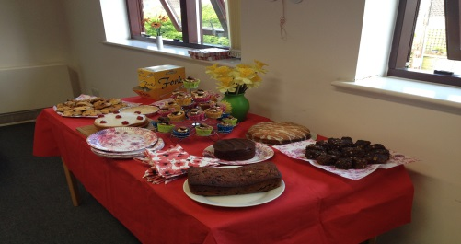

If you are a carer and are not already registered as being one, then there is a form available at reception, we will then put you on our Carer Register.
Carer Support Wiltshire is a charity that was created in 2011 to provide free confidential advice, help and support to carers aged 18 and over, across Wiltshire (excluding Swindon).
It is open to those who give unpaid care to a child or adult in their day to day life because they could not manage without some support. It is a network charity of the Carers Trust, and works closely with local GP surgeries to ensure that carers have a good support system open to them, such as free counselling, benefits advice, complementary therapies, support groups and training.

For more information about Carer Support and their upcoming events, please speak to Linda Harries or look on the board in reception with information about what Carers Support Wiltshire can offer you.
If you are a young carer please contact Spurgeons on 01666 825566 or email malmsburycc@spurgeons.org
Help the NHS save money!

Did you know?
As part of efforts to save money within the NHS, we try to encourage you to buy some minor-ailments treatments over the counter rather than have them prescribed.
The following is a small sample that can be bought at a reasonable cost over the counter at retail pharmacies:
Antihistamines, Chloramphenicol eye drops, Aqueous Cream, Hydrocortisone, Doublebase, Aveeno, Aciclovir Cream & Oilatum. Fybogel Type products, Dioralyte Sachets, Mebeverine, Loperamide, Anusol Cream and suppositories, some thrush preparations.
There has been lots of talk recently regarding the ‘Minor Ailments Scheme’. Wiltshire NHS do not offer this service. But your pharmacist can advise you on many ‘minor illnesses’ such as coughs, constipation, hay fever, allergies, diarrhea, threadworms, nappy rash and teething. A more comprehensive list is available online.
Other News

By the time this Newsletter is published we hope the internal door to the waiting room will have been changed to an automatic one. Thanks go to a very generous patient who kindly purchased this for the surgery.
There have been leaflets delivered lately from a company based in Leeds called Pharmacy 2u. This company and its services have no affiliation with New Court Surgery. If you have any queries regarding it or its services we suggest speaking either to them or failing that your local pharmacy.
In April the surgery held a Bake for Heroes cake sale and raised £141 for Help for Heroes. We had a lovely selection of cakes and other fancies, Thank you to everyone who helped in supporting this worthy charity.
FONCS News

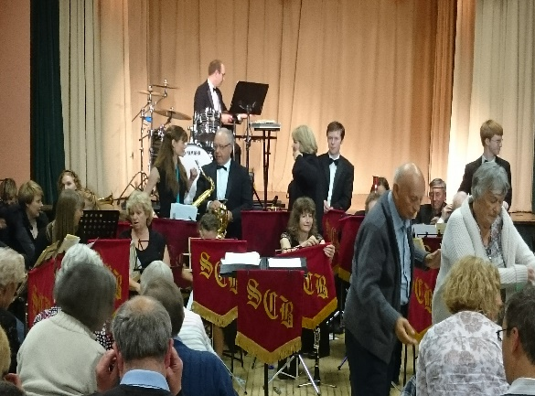
On Friday 15th May FONCS held its annual Spring Concert at the Royal Wootton Basset Memorial Hall. The Swindon Concert Band entertained a packed hall with a wonderful repertoire from the classical tones of Strauss to the modern beat of Sir Elton John. Demonstrating a breadth of musical knowledge Malcolm Webb (Musical Director) kept us enthralled with his witty tales and interesting facts coupled with the excellent performance of the band ensured the audience enjoyed this fabulous toe- tapping evening.

The event raised a magnificent £915 to provide additional facilities for all our New Court patients.

So a big thank you to the Swindon Concert Band, the Bar Staff and for your support to this event
Foncs run a volunteer driver (taxi) scheme, for those patients who have difficulty getting to and from medical appointments. A small charge is made to cover the costs. Equally if you are a driver and find you have spare time and feel you could help us then please pick up an enquiry form from reception.
Coming up shortly there will be the annual quiz night which is always a great event and always a sell out! More details nearer the time.
Foncs also run their own lottery club! Members donate £1 per month (payable in advance, and preferably by standing order). 50% of the money collected is given back in prize money each month. There are 3 prize amounts of £100, £25 and 3 prizes of £10. Winning names are published each month on the TV screen in the waiting room and on the FONCS notice board in the waiting room. If you would like to join please ask reception for a form or see the website for more details.
FONCS – Here to help you by helping your surgery.
Diabetes Roadshow

The prevalence of diabetes both nationally and in Wiltshire is rising. There are currently around 21,788 patients with diabetes diagnosed in Wiltshire and an estimated further 7,000 people remain undiagnosed. Public Health at Wiltshire Council are running a campaign to raise awareness of Type 2 Diabetes, focussing on the importance of prevention through maintaining a healthy weight and encouraging early diagnosis. We shall be touring Wiltshire with Diabetes UK during July to offer residents a free type 2 diabetes NICE approved risk assessment based upon a set of questions and measurements. Those who are given a 'moderate' or 'high' risk assessment will be signposted to their local GP practice for further support which may include a blood test. There will also be a dietician and health trainers on site to offer support to those with established diabetes.
Date | Location
Tuesday 7th July 2015 | Trowbridge- Fore Street
Wednesday 8th July 2015 | Melksham- Sainsbury (Bath Road)
Thursday 9th July 2015 | Chippenham- Butter Cross
Friday 10th July 2015 | Devizes -Market Place car park
Thursday 23rd July 2015 | Salisbury- Market Place
Friday 24th July 2015 | Salisbury- Market Place

Next Newsletter Autumn/Winter 2015

